Quantum Computing  
  
Its based on the concepts of quantum physics  
  
  
So far we know about classical computing and classic physics, that makes the computers today run algorithms for example:

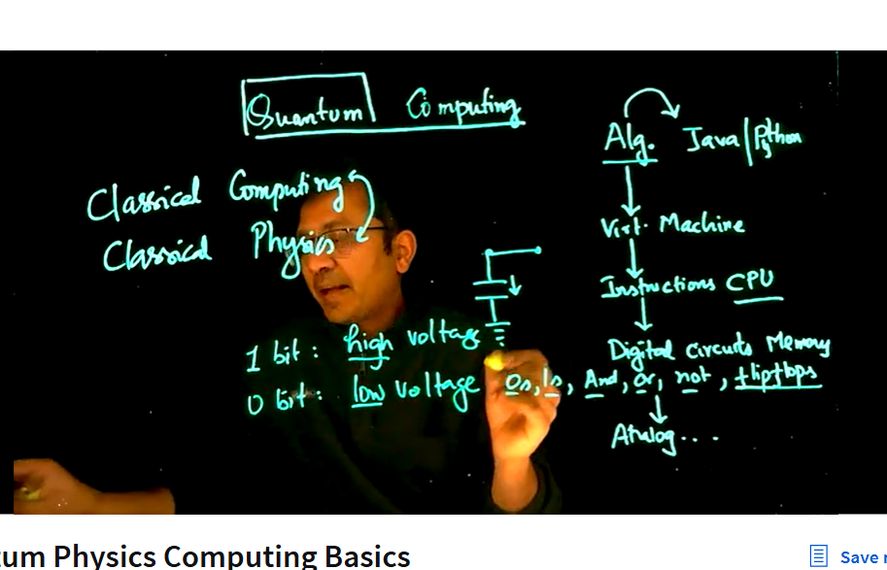

At the core fundamental level we have just discharging of components for example 1 to 0 or to 0 to 1

Principles of Quantum Physics:  
Quantization  
Heisenbugs: Means things can exist at different states till the point we measure it  
  
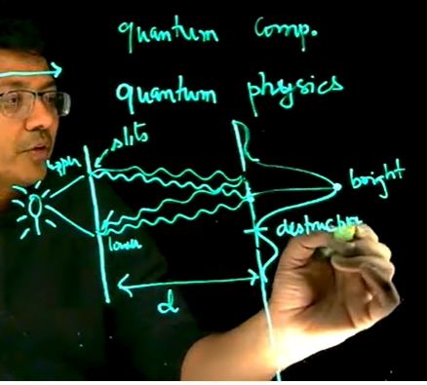  
Constructive and Destructive Interferences  
  
When the source of light is very dim, then it emits just one photon from the source of light through the upper or lower slit, so there would be no interference pattern as in the classic pattern the lights from upper slit and lower slit with proper intensity arrive and create interference patterns

Superposition

* Quantum System can exist in multiple states at the same time
* In Quantum mechanism is where photo can have multiple sates and creates interference
* Schrodinger’s Cat Experiment
* Electrons can be only in some discrete orbits

Measurement: Any kind of interaction of the electrons with something, that is what we are taking in account when we take the word measurement into consideration in order words causes of collapse  
We cannot measure something without any interactions  
  
  
Experiment to understand Quantum Mechanics:  
  
Stern garlic experiment:  
The Stern–Gerlach experiment was meant to test the Bohr–Sommerfeld hypothesis that the direction of the angular momentum of a silver atom is quantized  
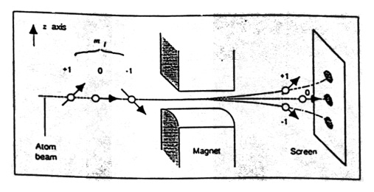  
  
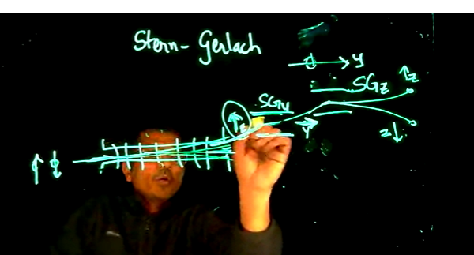  
In this case when we create a measurement along an axis in the case the Prof. is pointing at y axis so the other rays goes away. So measurement filters out the things along different axis

1. Quantum Elements can exists a the same time which is basically called superposition.
2. Many types of interaction can cause superposition to collapse which is called the measurements
3. Entanglement

Using these three points we create the quantum computers while we understand concepts of Quantum parallelism. Where we create algorithm through which we are able to a higher probability to get the right answer